Predictability and Market Efficiency: A Comprehensive Analysis of the Israeli Stock Market

Kfir Saroussi

Southwest Uni, Bulgaria

Abstract:
This study examines the efficiency of the Israeli stock market through a comprehensive analysis of the MAOF Index. We test both weak and semi-strong forms of market efficiency using data from 1991 to 2005. Our methodology incorporates time series analysis, macroeconomic variables, and a binary choice model to test market predictability. The results challenge both the weak and semi-strong forms of market efficiency hypotheses. We find significant predictive power in historical price patterns with an 11-month lag structure, and demonstrate that publicly available macroeconomic information, particularly changes in current account deposits and geopolitical events, can predict market movements. Our trading strategy based on these findings generates substantial excess returns compared to a passive buy-and-hold approach. These results have important implications for market efficiency theory and investment strategies in emerging markets.

Keywords: Market Efficiency; Israeli Stock Market; the MAOF Index.

Received: 09 January 2025
First revision: 21 January 2025
Accepted: 14 February 2025

Introduction

The efficiency of financial markets remains a cornerstone of modern financial theory and continues to generate significant academic debate. While extensive research has examined market efficiency in developed markets, emerging markets present unique characteristics that warrant specific investigation. The Israeli stock market, represented by the MAOF Index, offers a particularly interesting case study due to its sophisticated market structure combined with distinctive local factors affecting market behavior.
This paper investigates the validity of the Efficient Market Hypothesis (EMH) in the context of the Israeli stock market, focusing on both weak and semi-strong forms of market efficiency. Our analysis extends beyond traditional efficiency tests by incorporating macroeconomic variables and geopolitical factors specific to the Israeli market environment.
The primary objectives of this study are threefold: (1) to test the weak-form efficiency through analysis of historical price patterns, (2) to examine semi-strong efficiency by evaluating the predictive power of publicly available information, and (3) to assess the economic significance of any identified inefficiencies through simulated trading strategies.
Our study contributes to the existing literature in several important ways. First, we provide comprehensive evidence on market efficiency in an emerging market context during a period of significant economic and political transformation. Second, we employ a novel methodological approach that combines traditional efficiency tests with macroeconomic variables and geopolitical factors. Third, we demonstrate the economic significance of our findings through implementable trading strategies. The remainder of this paper is organized as follows: Section II reviews the relevant literature, Section III describes our data and methodology, Section IV presents our empirical results, Section V discusses the implications of our findings, and Section VI concludes.

Literature Review
The literature on market efficiency has evolved significantly since Fama's (1970) seminal work on the Efficient Market Hypothesis (EMH). This evolution reflects both theoretical refinements and empirical challenges to the traditional framework. We structure our review around three key themes: the theoretical foundations of market efficiency, the special characteristics of emerging markets, and the specific context of the Israeli market.
The theoretical foundations of market efficiency are rooted in the Efficient Market Hypothesis (EMH), which asserts that asset prices fully reflect all available information (Fama, 1970). While the EMH has significantly influenced financial theory, it faces challenges from behavioral finance, which highlights the role of investor irrationality and psychological biases (Hodnett & Hsieh, 2012).

Market efficiency can coexist with heterogeneous beliefs and individual irrationality; however, during periods of market euphoria or pessimism, deviations from efficiency may occur (Pesaran & Pearson, 2010). The concept of efficiency has evolved, with some suggesting that markets become more efficient when analysts perceive inefficiencies and compete to exploit them (Quiroga, 2017). Recent studies examine the impact of technological advancements on market efficiency (Li, 2024). Despite its limitations and evidence of anomalies, the theory of market efficiency has profoundly enhanced our understanding of stock markets and financial systems (Ball, 1994).
Market efficiency theory identifies three distinct forms of efficiency, each reflecting varying levels of informational integration. As explained by Mallikarjunappa (2010), these are the weak, semi-strong, and strong forms of efficiency. The weak form suggests that current prices incorporate all historical price information. The semi-strong form posits that prices integrate all publicly available information. The strong form, the most rigorous, argues that prices reflect all available information, including insider knowledge.
However, contemporary research has increasingly challenged these traditional classifications. McGoun (1990) presents a fundamental critique, arguing that weak-form efficiency is inherently non-testable, while strong-form inefficiency is definitionally true. This theoretical tension has spurred a rich empirical literature examining various aspects of market efficiency. Lo and MacKinlay (2001) and Campbell et al. (2018) document significant predictable patterns in stock returns across various markets, challenging the basic premises of market efficiency.
Emerging markets pose significant challenges to the Efficient Market Hypothesis (EMH) framework, as they often exhibit distinct efficiency characteristics compared to developed markets. Studies by Bekaert and Harvey (2017) highlight several factors that contribute to these differences (Bekaert, & Harvey, 2003). Lower liquidity levels in emerging markets can impede the rapid incorporation of information into prices, potentially leading to inefficiencies (Oprean, 2012; Bekaert, Harvey & Lundblad, 2007). Information asymmetry is more prevalent in these markets, with less sophisticated intermediaries and limited access to reliable company information (Oprean, 2012). Regulatory framework differences, including weaker corporate governance and disclosure requirements, can further hinder market efficiency (Kofarbai & Zubairu, 2016). Additionally, variations in market microstructure, such as trading mechanisms and transaction costs, can impact the price discovery process (Muzaffar & Malik, 2024). These factors collectively contribute to the unique challenges faced by emerging markets in achieving the level of efficiency proposed by the EMH, necessitating a more nuanced approach to understanding and analyzing these markets.
The Israeli stock market exhibits unique characteristics, including high technology sector concentration and significant geopolitical influences (Rothman & Yakar, 2019). The Tel Aviv Stock Exchange (TASE) and particularly the MAOF Index has shown strong integration with international markets, particularly for Israel and Turkey (Cheng et al., 2010). However, the Israeli government and banks still play a dominant role in financial markets (Blass et al., 1997). The TASE demonstrates distinctive investor behavior patterns, such as higher returns following weekends and holidays, contrary to international evidence (Lauterbach & Ungar, 1992). Market orientation has been linked to business performance in Israel (Shoham & Rose, 2001).

The TASE has also shown a significant equilibrium relationship with the Palestine Stock Exchange (Suryanto & Hadi, 2015). Technical analysis of the Tel-Aviv 25 Index has been compared to the S&P 500 to examine market efficiency (Shachmurove et al., 2001). These studies highlight the unique aspects of the Israeli market context.
The unique characteristics of emerging markets present particular challenges to the EMH framework. Bekaert and Harvey (2003) identify several structural factors that distinguish emerging markets from their developed counterparts. These include lower liquidity levels, which Bekaert, Harvey, and Lundblad (2007) show can impede efficient price formation, and information asymmetries that Oprean (2012) demonstrates are more prevalent in emerging market contexts.
The Israeli market presents a particularly interesting context for examining market efficiency. Rothman and Yakar (2019) highlight the market's distinctive characteristics, including its high concentration of technology sector firms and unique geopolitical influences. The Tel Aviv Stock Exchange (TASE), and particularly the MAOF Index, demonstrates strong international market integration, especially with other Middle Eastern markets as documented by Cheng et al. (2010). However, as Blass et al. (1997) note, the market retains unique structural features, including significant government and banking sector influence on financial markets.
Empirical evidence specific to the Israeli market reveals several anomalies that challenge traditional efficiency assumptions. Lauterbach and Ungar (1992) document distinctive patterns in returns following weekends and holidays that contradict international evidence. These patterns suggest potential predictability that may be exploited through appropriate trading strategies. Furthermore, Shachmurove et al. (2001) provide comparative analysis of the Tel-Aviv 25 Index and the S&P 500, offering insights into the relative efficiency of the Israeli market in a global context.
The relationship between macroeconomic variables and stock market behavior in emerging markets warrants particular attention. As Chen et al. (2016) demonstrate, traditional macroeconomic indicators may have different implications in emerging market contexts. This is particularly relevant for the Israeli market, where Suryanto and Hadi (2015) find significant equilibrium relationships with regional markets, suggesting potential predictability based on regional economic indicators.

Data and Methodology
Our empirical analysis employs monthly data from the MAOF Index spanning from 1991 to 2005, complemented by macroeconomic variables and geopolitical indicators. The methodology follows a three-stage approach to test market efficiency:

First Stage
Testing Weak-Form Efficiency We begin by examining the stationarity properties of the MAOF Index returns using augmented Dickey-Fuller tests. This is followed by autocorrelation analysis to identify potential predictable patterns in returns.
The stationarity test results Dependent Variable: MAOF Method: L.S.

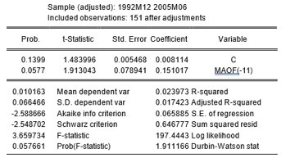

he change MAOF(-11) is significant at the 94% level, so is the rule-for, the concept is that for any given month, if you want to get a forecast, you must check 11 months back and between the above-mentioned months there is a positive correlation (observation examples for January will be obtained by placing the month of February of the previous year.) Level of explanation
(2.3%) is small
From the residual tests - the K value is close to 3 and the S value is close to 0 - p>5% after the residuals are normally distributed, a skip of 11 months as a variable does not contribute to heteroskedasticity according to the Breusch test, p>5% in addition to the previous output according to the D.W. value.
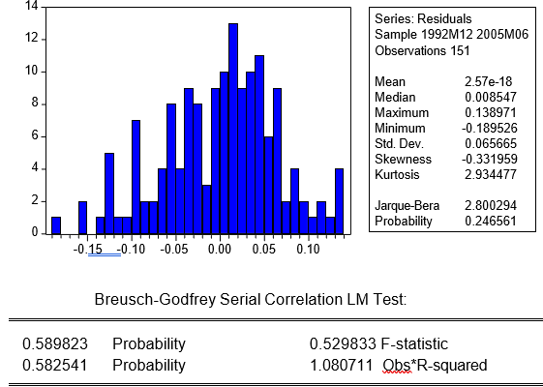
Since these are the returns of the MAOF index, you can run the model and get a forecast for the MAOF index and according to that act to enter the market if the forecast is positive and exit if the forecast is negative (B&1/0) and compare it against a passive strategy of 'buy and hold' - (B&H)
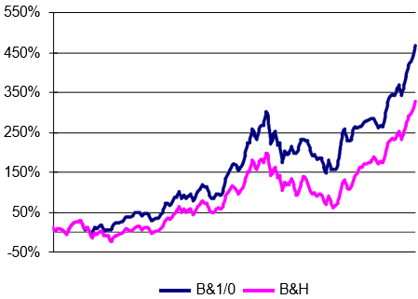

Second Stage:
Testing Semi-Strong Efficiency, We extend our analysis to incorporate publicly available information using a set of macroeconomic variables including:
- Current account deposits
- Total public assets
- Money supply measures
- Geopolitical event indicators
The correlation matrix
MAOF | DUMI | BITUAH | MZUMAN | PAHAK | MAKAM | SAHE | SAHN | OSH
-0.252819 | -0.058776 | -0.042244 | 0.302656 | 0.235830 | 0.030069 | 0.360657 | 0.953729 | 1.000000 | OSH
-0.215063 | 0.007568 | -0.011393 | 0.348573 | 0.206334 | -0.019953 | 0.340707 | 1.000000 | 0.953729 | SAHN
-0.160185 | 0.044316 | 0.026524 | 0.431605 | 0.347796 | -0.094116 | 1.000000 | 0.340707 | 0.360657 | SAHE
-0.115477 | 0.091145 | 0.004334 | -0.237626 | -0.052917 | 1.000000 | -0.094116 | -0.019953 | 0.030069 | MAKAM
-0.080239 | -0.009674 | 0.041839 | -0.168984 | 1.000000 | -0.052917 | 0.347796 | 0.206334 | 0.235830 | PAHAK
-0.073854 | 0.044955 | 0.061390 | 1.000000 | -0.168984 | -0.237626 | 0.431605 | 0.348573 | 0.302656 | MZUMAN
-0.064565 | -0.003554 | 1.000000 | 0.061390 | 0.041839 | 0.004334 | 0.026524 | -0.011393 | -0.042244 | BITUAH
-0.200613 | 1.000000 | -0.003554 | 0.044955 | -0.009674 | 0.091145 | 0.044316 | 0.007568 | -0.058776 | DUMI
1.000000 | -0.200613 | -0.064565 | -0.073854 | -0.080239 | -0.115477 | -0.160185 | -0.215063 | -0.252819 | MAOF

The regression results with macroeconomic variables,
Dependent Variable: MAOF, Method: L.S.

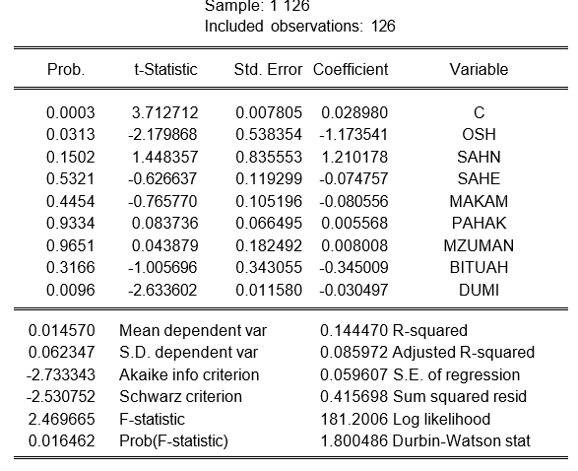

Third Stage:

Trading Strategy Implementation
To assess the economic significance of our findings, we develop, and test trading strategies based on our statistical models. We compare the performance of these active strategies against a passive buy-and-hold approach. The trading rules are implemented as follows:

For the weak-form efficiency test:
Long position initiated when the 11-month lag model predicts positive returns
Position liquidated when the model predicts negative returns
Transaction costs are considered in the implementation

For the semi-strong efficiency test:
We construct a binary choice model incorporating macroeconomic variables and geopolitical indicators to predict market direction:

P(Mt = 1) = F(c + β1·dumit-1 + β2·osht-1)

Where:
Mt represents market state (1 for bullish, 0 for bearish)
dumit-1 captures geopolitical events
osht-1 represents changes in current account deposits
The probit model results-
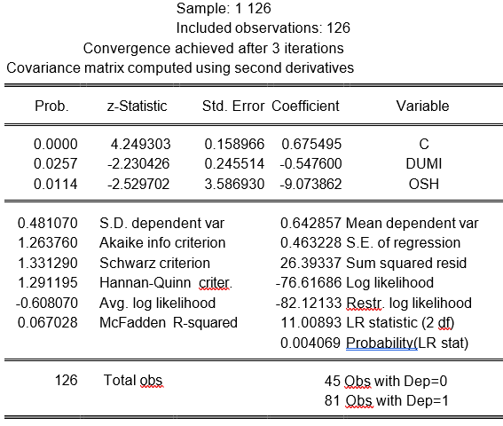

Empirical Results

Semi-Strong Efficiency Tests
The examination of macroeconomic predictors yields several significant relationships. Most notably, changes in current account deposits demonstrate strong predictive power for future market movements.

Estimation Command:
===================== LS MAOF C MAOF(-11)
Estimation Equation:
===================== MAOF = C(1) + C(2)*MAOF(-11)

Substituted Coefficients:
=====================
MAOF = 0.008113876936 + 0.1510170489*MAOF(-11)

The autocorrelation analysis reveals significant patterns at the 11-month lag, challenging the random walk hypothesis implied by weak-form efficiency.

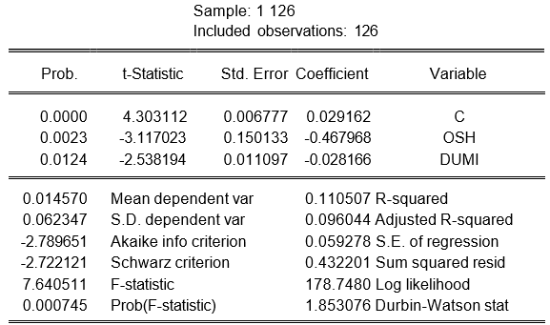

- The correlation coefficients
MAOF | DUMI | BITUAH | MZUMAN | PAHAK | MAKAM | SAHE | SAHN | OSH
-0.252819 | -0.058776 | -0.042244 | 0.302656 | 0.235830 | 0.030069 | 0.360657 | 0.953729 | 1.000000 | OSH
-0.215063 | 0.007568 | -0.011393 | 0.348573 | 0.206334 | -0.019953 | 0.340707 | 1.000000 | 0.953729 | SAHN
-0.160185 | 0.044316 | 0.026524 | 0.431605 | 0.347796 | -0.094116 | 1.000000 | 0.340707 | 0.360657 | SAHE
-0.115477 | 0.091145 | 0.004334 | -0.237626 | -0.052917 | 1.000000 | -0.094116 | -0.019953 | 0.030069 | MAKAM
-0.080239 | -0.009674 | 0.041839 | -0.168984 | 1.000000 | -0.052917 | 0.347796 | 0.206334 | 0.235830 | PAHAK
-0.073854 | 0.044955 | 0.061390 | 1.000000 | -0.168984 | -0.237626 | 0.431605 | 0.348573 | 0.302656 | MZUMAN
-0.064565 | -0.003554 | 1.000000 | 0.061390 | 0.041839 | 0.004334 | 0.026524 | -0.011393 | -0.042244 | BITUAH
-0.200613 | 1.000000 | -0.003554 | 0.044955 | -0.009674 | 0.091145 | 0.044316 | 0.007568 | -0.058776 | DUMI
1.000000 | -0.200613 | -0.064565 | -0.073854 | -0.080239 | -0.115477 | -0.160185 | -0.215063 | -0.252819 | MAOF

The binary Probit choice model provides additional evidence against market efficiency, with significant predictive power for market direction:

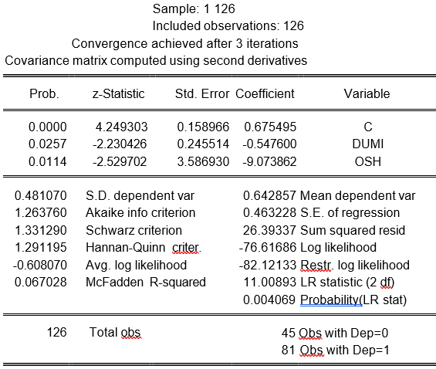

Trading Strategy Performance
The implementation of our trading strategies generates substantial excess returns compared to a passive buy-and-hold approach. The weak-form efficiency trading strategy based on the 11-month lag structure achieves a cumulative return of 141% above the buy-and-hold strategy.
The semi-strong efficiency trading strategy, incorporating macroeconomic variables and geopolitical indicators, demonstrates even stronger performance, achieving a cumulative excess return of 380% over the sample period. When implementing the binary choice model with a 60% probability threshold for market entry, the strategy yields return of approximately 950% above the passive buy-and-hold approach.

Discussion

Our findings present significant challenges to both weak and semi-strong forms of market efficiency in the Israeli stock market. The predictive power of historical returns, particularly at the 11-month lag, suggests persistent inefficiencies that cannot be explained by transaction costs or risk premiums. This finding aligns with Lo and MacKinlay's (2001) documentation of serial correlation in stock returns but demonstrates a longer-term predictability pattern specific to the Israeli market.
The significant predictive power of macroeconomic variables, particularly current account deposits, suggests that publicly available information is not fully incorporated into market prices. This inefficiency likely stems from the unique structural characteristics of the Israeli market documented by Blass et al. (1997). The strong relationship between current account deposits and market movements reflects the close connection between business cycles and market behavior, supporting Bekaert and Harvey's (2017) observations about emerging market characteristics.
The geopolitical factor's significance in our models aligns with Zach's (2003) findings regarding the impact of political events on the Israeli stock market. This suggests that while such information is public, the market's reaction to geopolitical developments may not be fully efficient, creating exploitable trading opportunities.

Conclusion

This study provides comprehensive evidence challenging the efficient market hypothesis in the context of the Israeli stock market. Our findings demonstrate significant predictability in both historical price patterns and through publicly available information, contradicting both weak and semi-strong forms of market efficiency. The economic significance of these inefficiencies, demonstrated through substantial excess returns from our trading strategies, suggests that these patterns are not merely statistical artifacts but represent genuine market inefficiencies.

The results have important implications for both academic research and practical investment strategy. For researchers, our findings suggest that market efficiency tests should consider longer-lag structures and market-specific factors, particularly in emerging market contexts. For practitioners, our results indicate potential profitable trading strategies, though implementation would require careful consideration of transaction costs and market impact.
Future research might explore whether similar patterns exist in other emerging markets and whether these inefficiencies persist as markets develop. Additionally, investigation of the microstructural factors contributing to these inefficiencies could provide valuable insights for market design and regulation.

Reference

Bekaert, G., & Harvey, C. R. (2003). Emerging markets finance. Journal of empirical finance, 10(1-2), 3-55.
Bekaert, G., Harvey, C. R., & Lundblad, C. (2007). Liquidity and expected returns: Lessons from emerging markets. The review of financial studies, 20(6), 1783-1831.
Blass, A., Yafeh, Y., & Yosha, O. (1998). Corporate governance in an emerging market: The case of Israel. Journal of Applied Corporate Finance, 10(4), 79-89.
Cheng, A. R., Jahan-Parvar, M. R., & Rothman, P. (2010). An empirical investigation of stock market behavior in the Middle East and North Africa. Journal of Empirical Finance, 17(3), 413-427.
Fama, E. F. (1970). Efficient capital markets. Journal of finance, 25(2), 383-417.‏
Finnerty, J. E. (1976). Insiders and market efficiency. The journal of finance, 31(4), 1141-1148.
Hsieh, H. H., & Hodnett, K. (2012). Cross-sector style analysis of global equities based on the Fama and French three-factor model. The International Business & Economics Research Journal (Online), 11(2), 161.‏
Jain, V. (2012). An insight into behavioral finance models, efficient market hypothesis and its anomalies. Researchers World, 3(3), 16.‏
Kofarbai, H. Z., & Zubairu, M. (2016). Efficient market hypothesis in emerging market-a conceptual analysis. European Scientific Journal, 12(25).

Lauterbach, B., & Ungar, M. (1992). Calendar anomalies: Some perspectives from the behaviour of the Israeli stock market. Applied Financial Economics, 2(1), 57-60.
Mallikarjunappa, T. (2010). A study of efficiency of the Indian stock market. Indian Journal of Finance, 4(5), 32-38.‏
McGoun, E. G. (1990). A re-evaluation of market efficiency measurement. Critical Perspectives on Accounting, 1(3), 263-274.
Mustafa, K. H., & Ahmed, A. M. (2020). A Critical Review of the Market Efficiency Concept. Shirkah: Journal of Economics and Business, 5(2), 271-285.
Muzaffar, Z., & Malik, I. R. (2024). Market liquidity and volatility: Does economic policy uncertainty matter? Evidence from Asian emerging economies. Plos one, 19(6), e0301597.
Oprean, C. (2012). Testing the financial market informational efficiency in emerging states. Review of Applied Socio-Economic Research, 4(2), 181-190.
Pesaran, B., & Pesaran, M. H. (2010). Time series econometrics using Microfit 5.0: A user's manual. Oxford University Press, Inc.
Quiroga-Parra, D. J., Torrent-Sellens, J., & Murcia Zorrilla, C. P. (2017). Usos de las TIC en América Latina: una caracterización. Ingeniare. Revista chilena de ingeniería, 25(2), 289-305.‏
Rothman, T., & Yakar, C. (2019). The Equity Research Program’s Effect on Technology Investors: The Tel-Aviv Stock Exchange Case Study.
Shachmurove, Y., BenZion, U., Klein, P., & Yagil, J. (2001). A Moving Average Comparison of the Tel-Aviv 25 and S & P 500 Stock Indices. University of Pennsylvania.
Shoham, A., & Rose, G. M. (2001). Market orientation: A replication, cross-national comparison, and extension. Journal of Global Marketing, 14(4), 5-25.
Suryanto, T., & Hadi, A. R. A. (2015). Capital Market Integration: Palestine and Israeli Experience. Al-Iqtishad: Jurnal Ilmu Ekonomi Syariah, 7(2), 197-206.
Zach, T. (2003). Political events and the stock market: Evidence from Israel. Available at SSRN 420242.

